STUDENT PROFILE CARD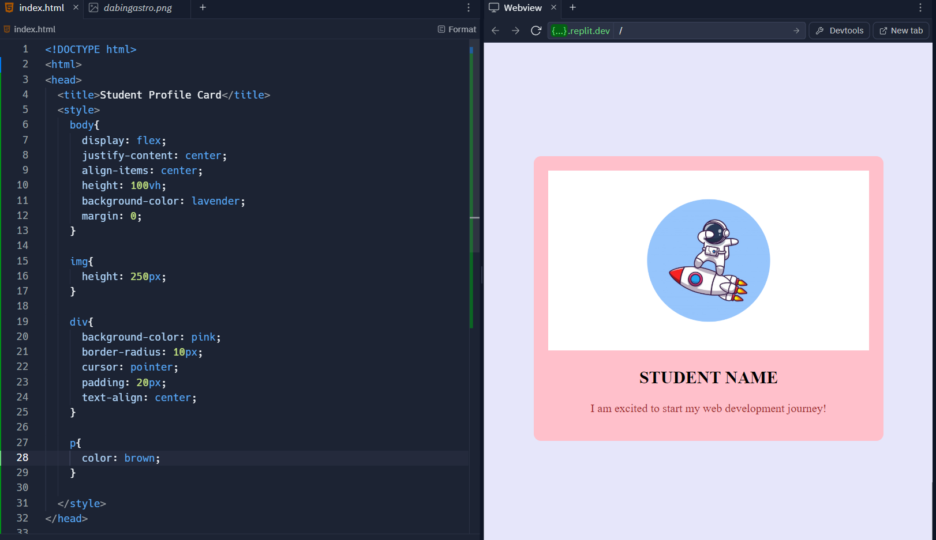

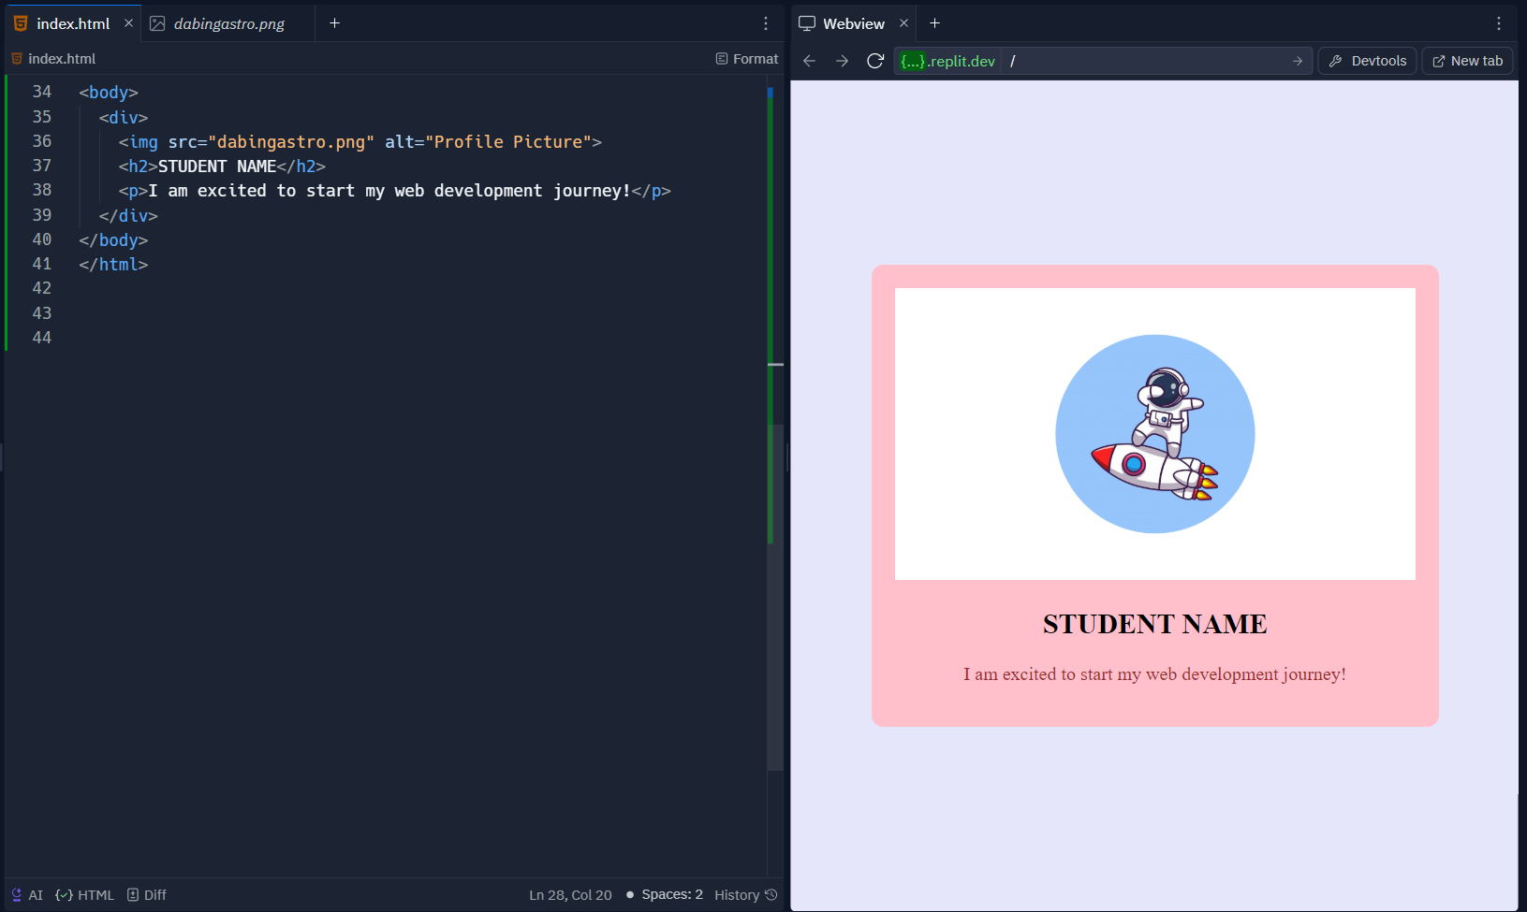

Emoji Board

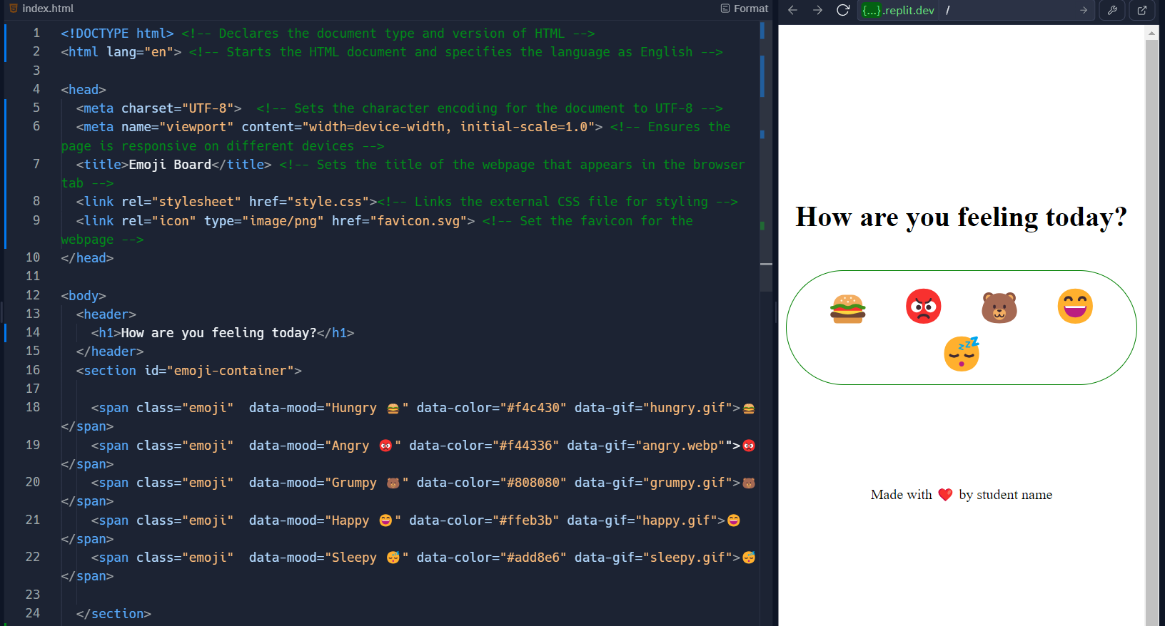

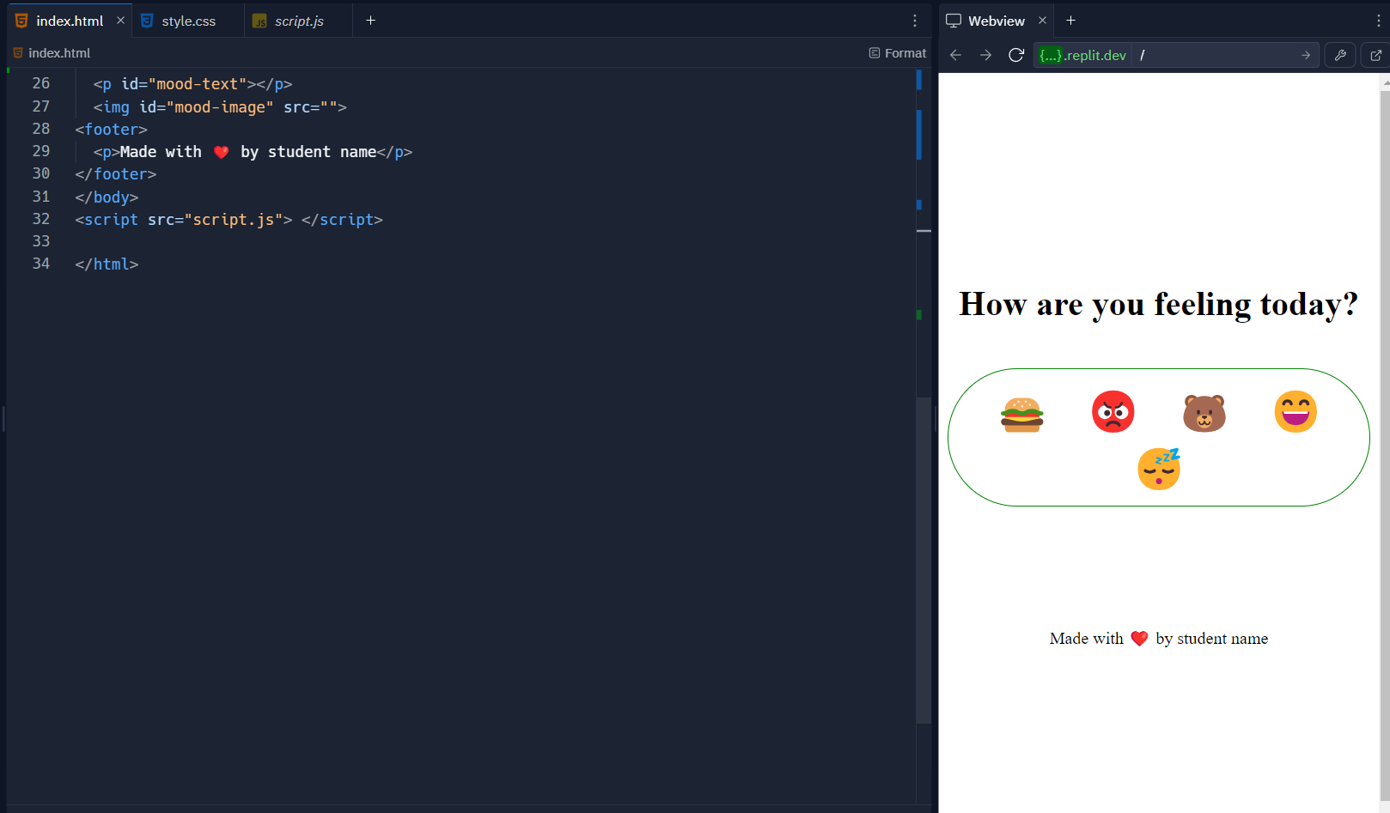

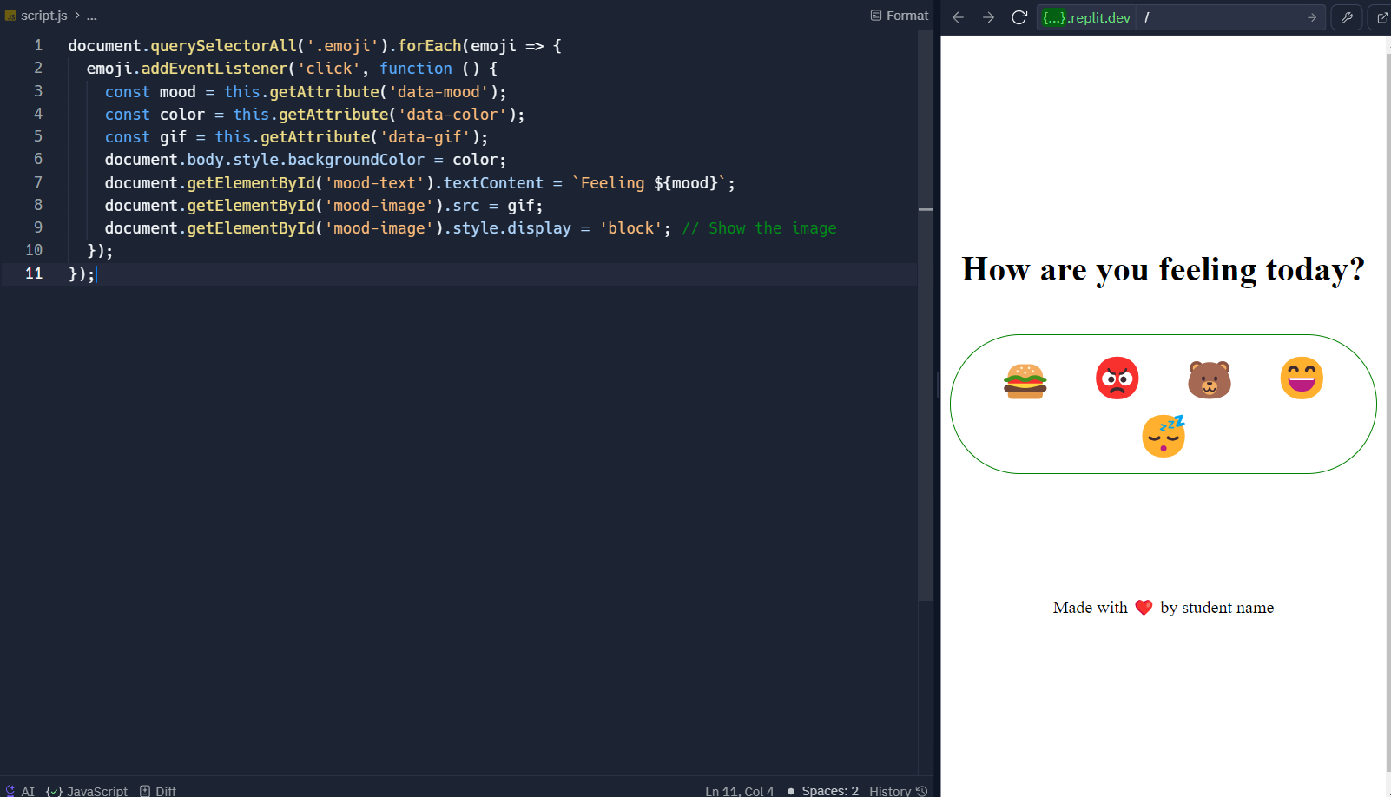

**data-mood="Hungry 🍔" data-color="#f4c430"**

**data-mood="Angry 😡" data-color="#f44336"**

**data-mood="Grumpy 🐻" data-color="#808080"**

**data-mood="Happy 😄" data-color="#ffeb3b**

**data-mood="Sleepy 😴" data-color="#add8e6"**

**❤️**

**Chatbot**

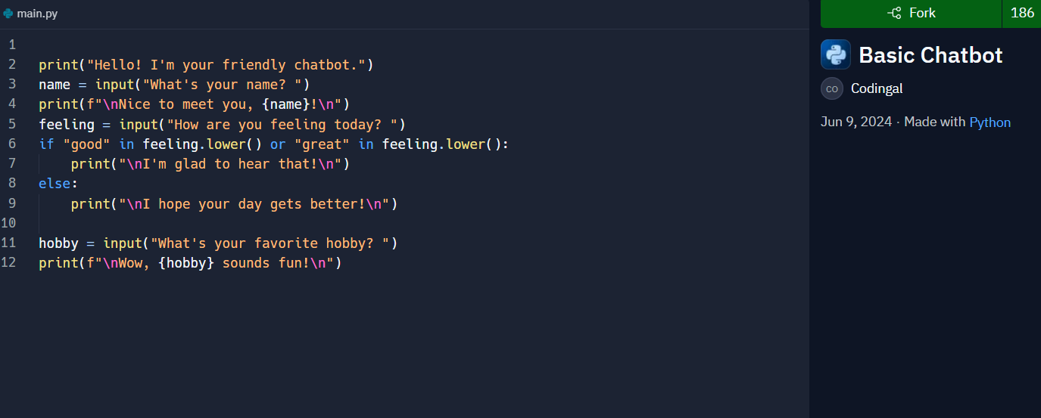

**Password Generator**

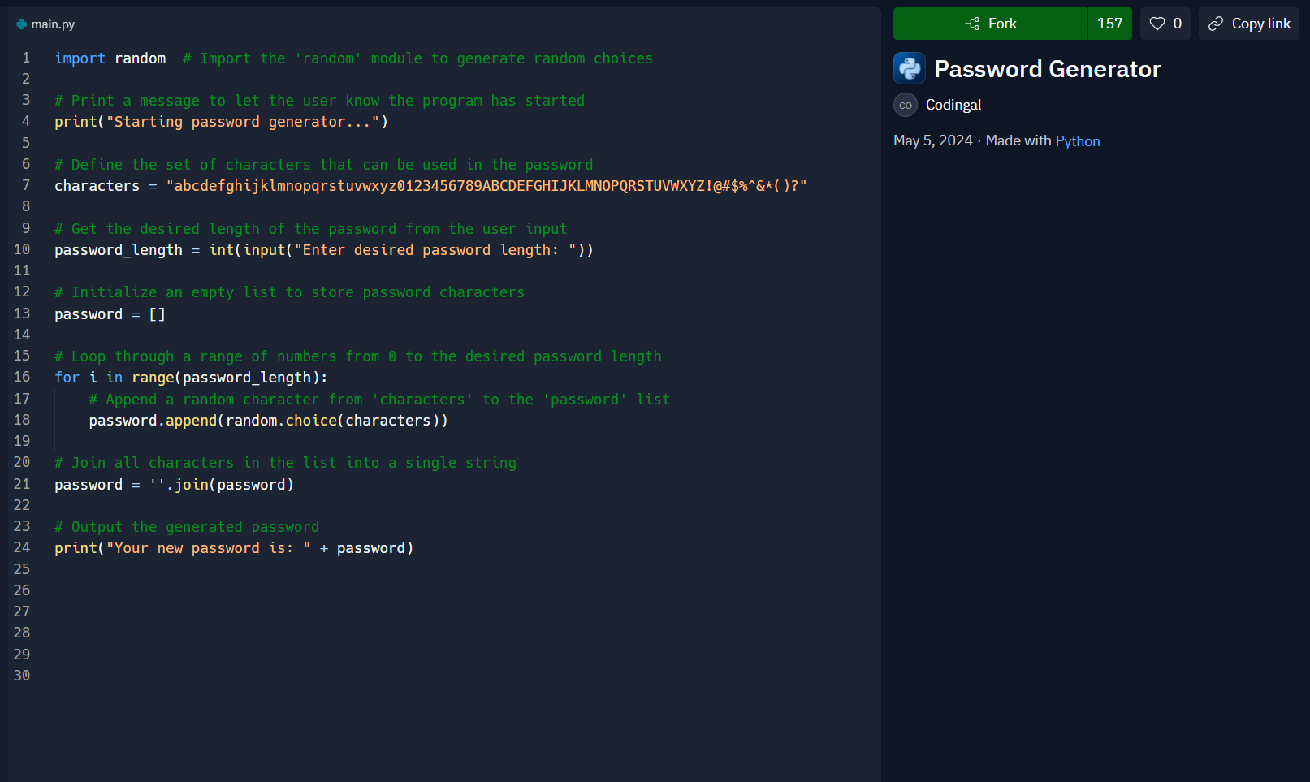

**Instagram**

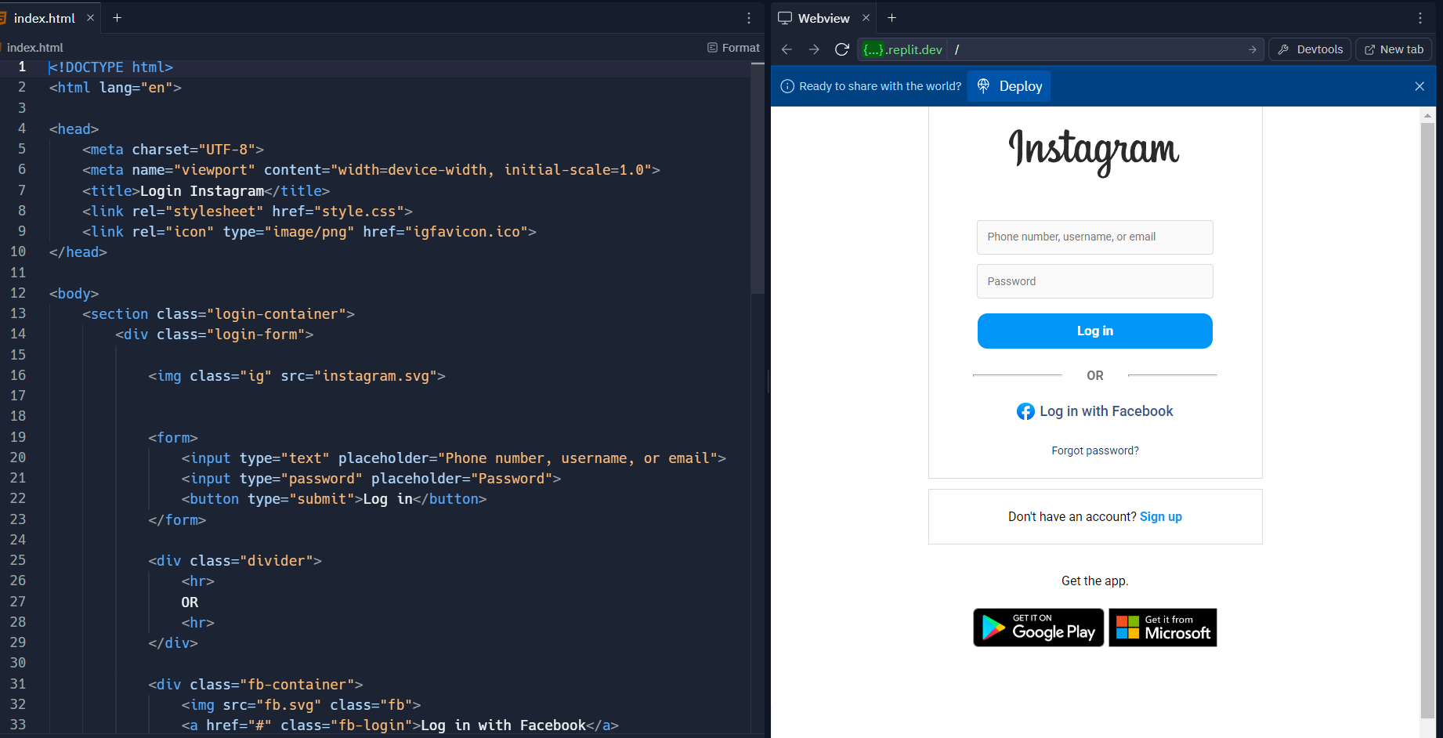

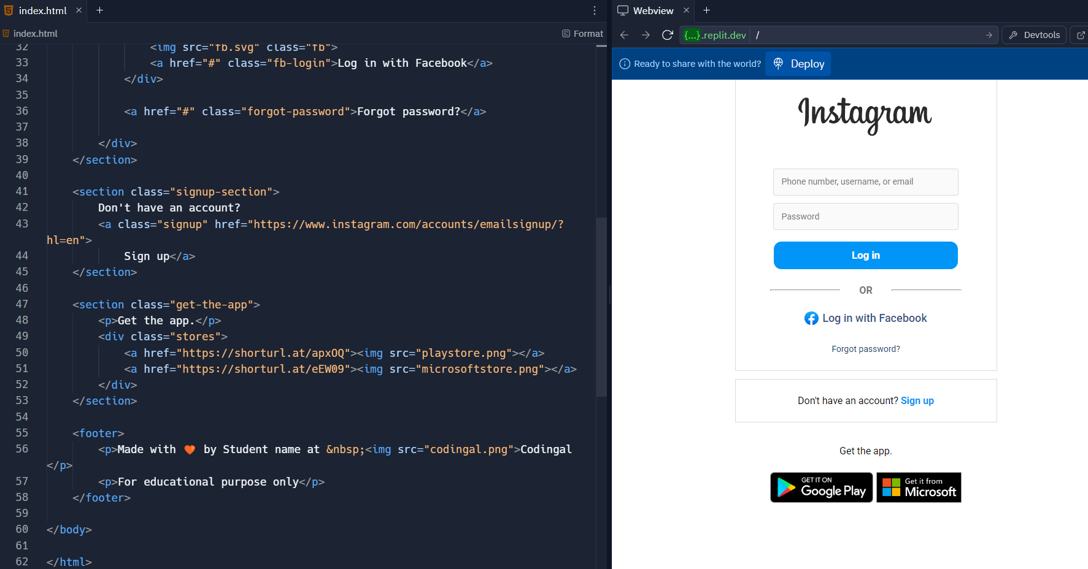

**AI MOOD DETECTOR:**

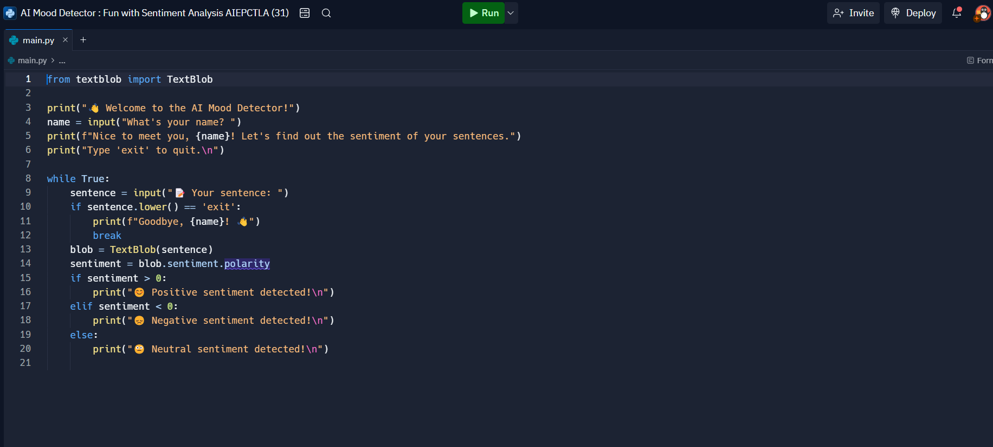

**AI GUESS MASTER**

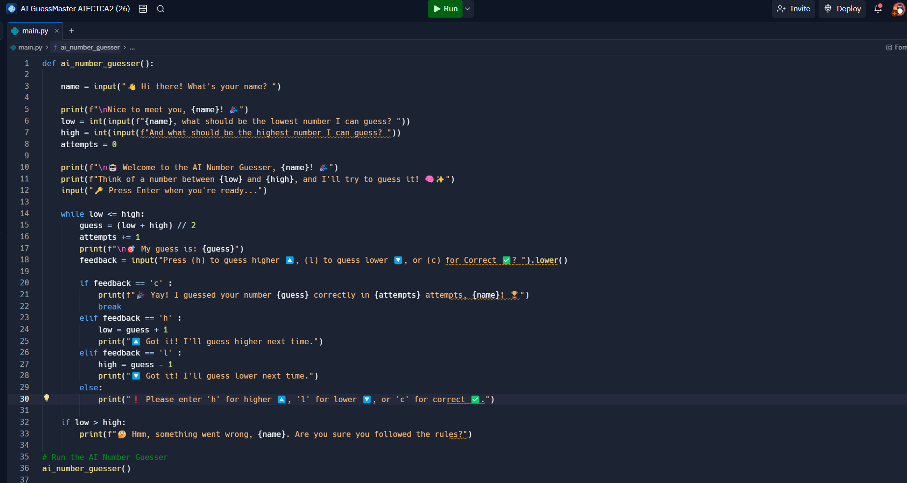

**AI ART BUDDY**

